|  |  |
| --- | --- |
| **EX.NO: 2**  **DATE: 02/09/2022** | **INSTALLATION OF C COMPILER AND EXECUTION OF SIMPLE PROGRAM IN VIRTUAL BOX** |

**AIM:**

To install a C compiler in the virtual machine created using virtual box and execute simple programs.

**STEPS:**

1. Download the installer file. It should probably be in the download folder by default, if you have not changed the settings in your browser.
2. Download the virtual box platform packages for your OS and open the installation package by double clicking.

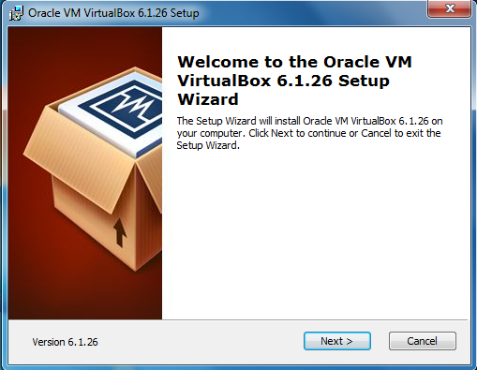

1. Choose the setup type and features to be installed.

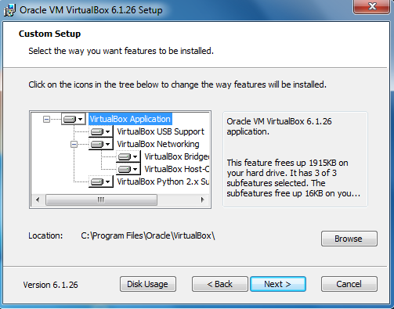

1. Choose from the above options about the preferred shortcut to be displayed.

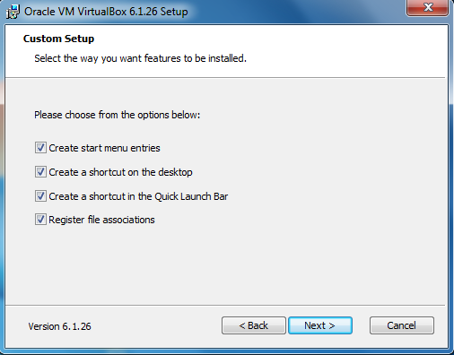

1. Click “install” to begin the installation of the setup.

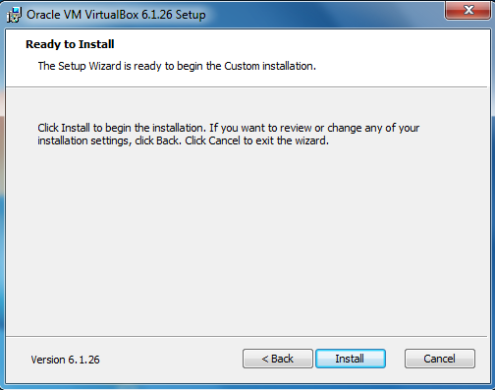

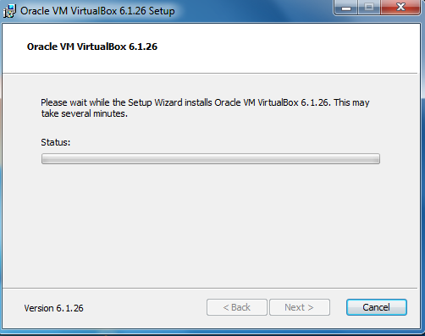

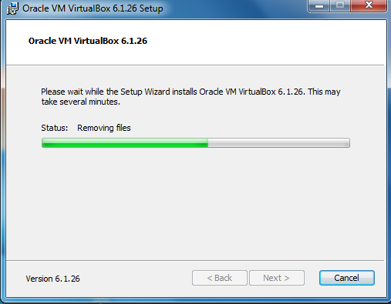

1. Click finish to complete the installation.

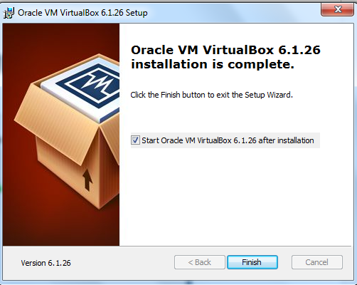

1. Launch the virtual box. After the installation completes, you should see the Oracle VMVirtualBox Manager icon on the desktop. Double click on it to launch the application.
2. Run the virtual box by double clicking the icon and then click “new” on the top right corner.

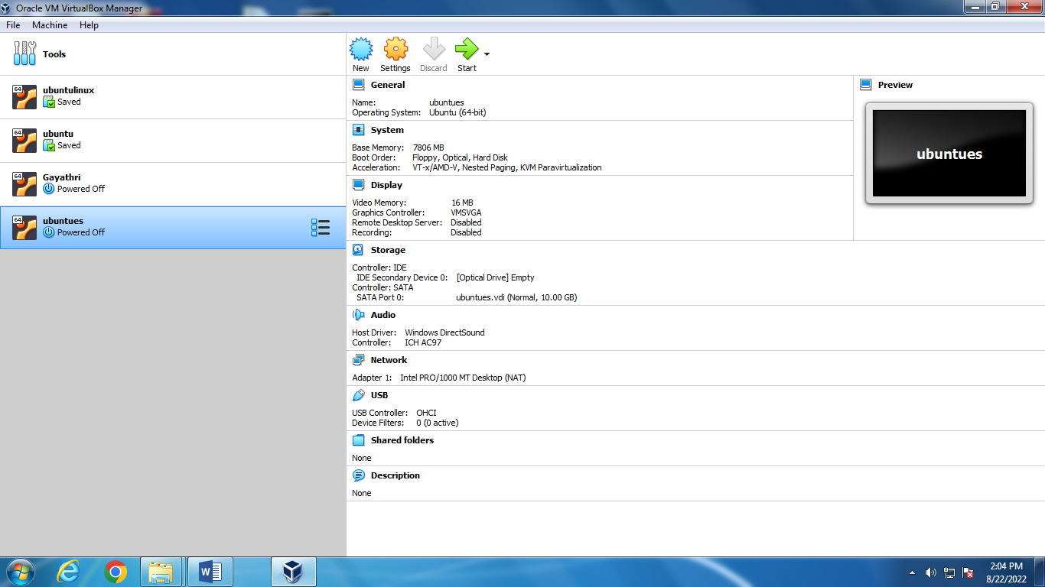

1. Click “continue” on the pop-up window. Type the VM name, select “Linux” for the OS and choose “Ubuntu” for the version.

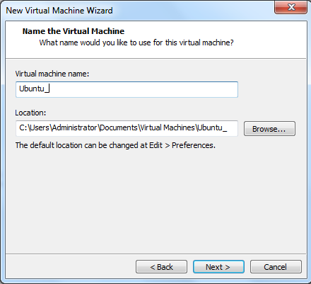

1. Choose the amount of memory to allocate, then click continue or next.

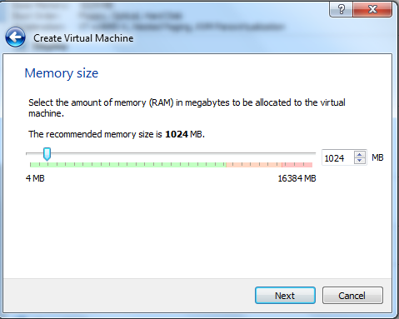

1. Choose “create a virtual hard disk now” and click “create”.

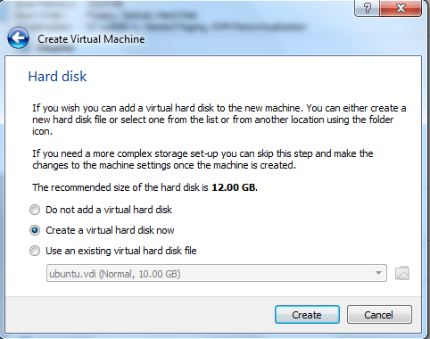

1. Choose VDI and click “next”.

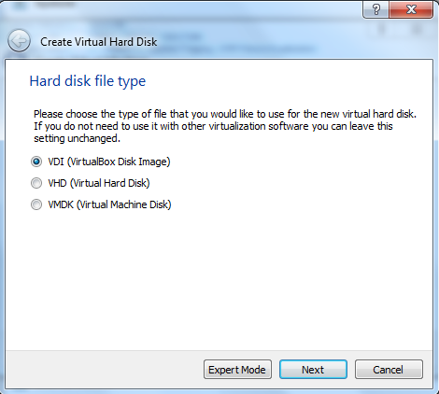

1. Choose “Dynamically allocated” and click “next”.

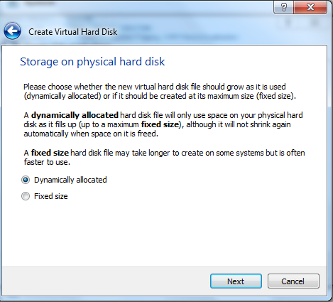

1. Click the folder icon and choose the ubuntu iso file that was downloaded. Select the size of the virtual disk and the click “create”.

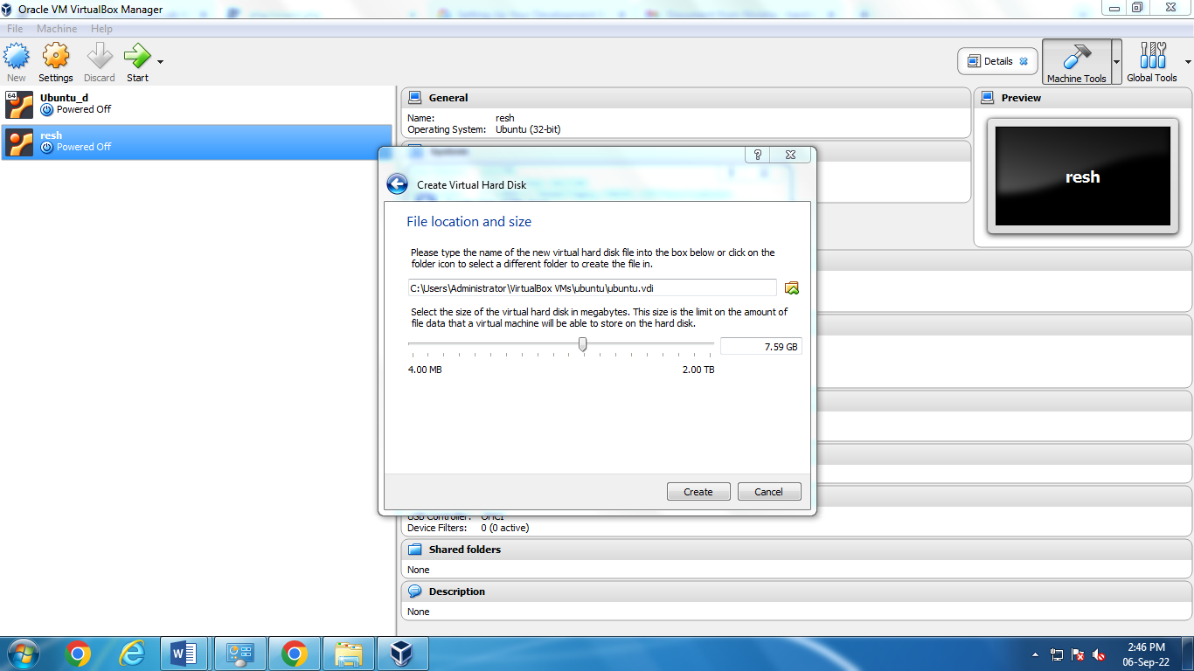

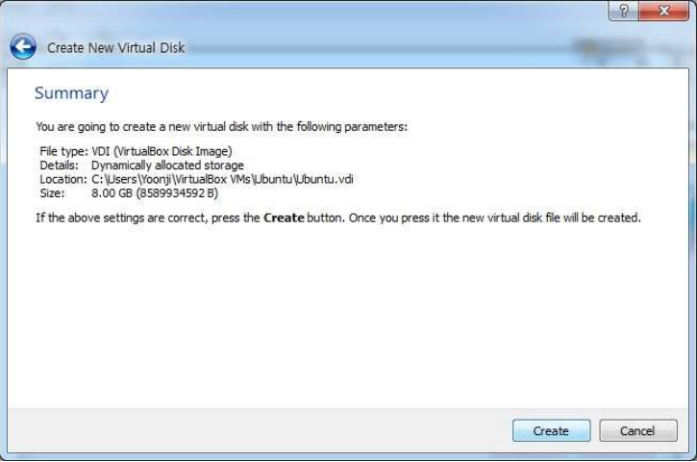

1. Click the file that you created and select “start”.



1. Open the terminal.

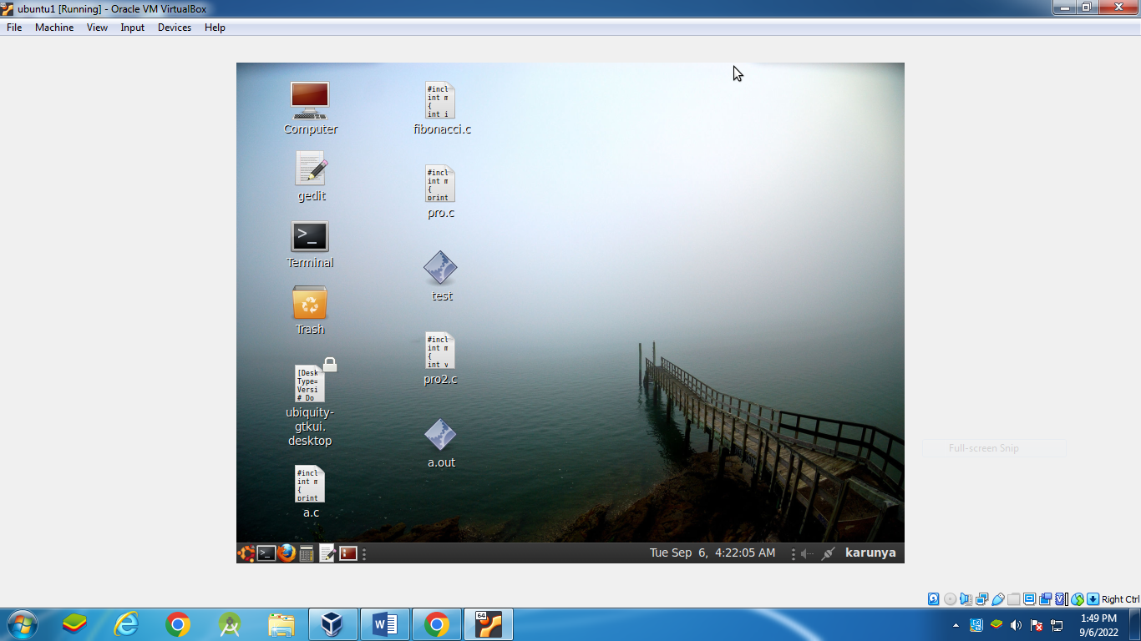

1. Open gedit by typing “gedit &” on terminal (You can also use any other Text Editor application). Create a new file and start typing your program.

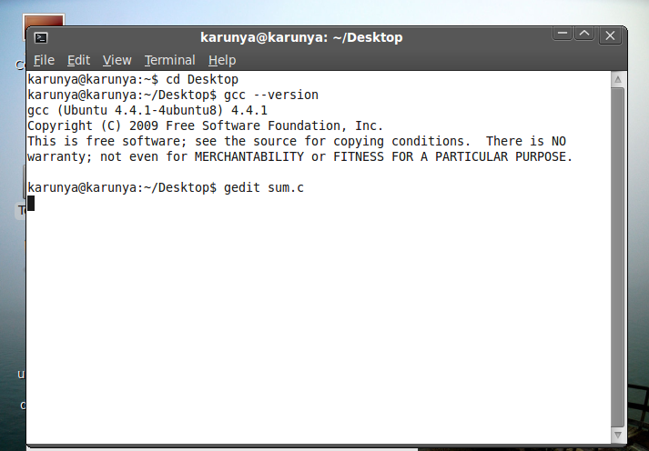

1. Type the code on getedit or some other text editor.

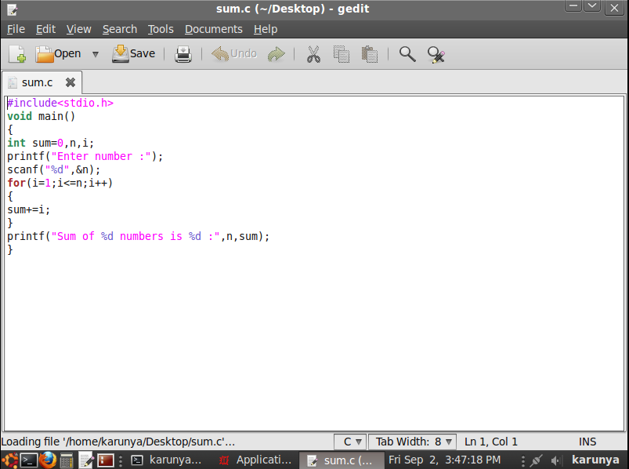

1. Type gcc -o sum sum.c to compile. Type ./sum. To run the program.

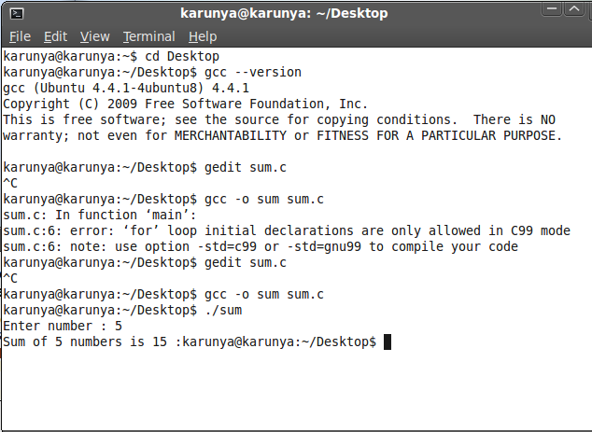

|  |  |
| --- | --- |
| **Prompt Completion (10)** |  |
| **Neatness (5)** |  |
| **Prompt Timing (10)** |  |
| **Total (25)** |  |

**RESULT:**

Thus, the installation of a C compiler in the virtual machine were created using virtual box and simple programs were successfully executed.